ASSIGNMENT 4.1

Problem Statement1 Write a Java program, to take a HDFS Path as input and display all the files and sub-directories in that HDFS path.

ANS)

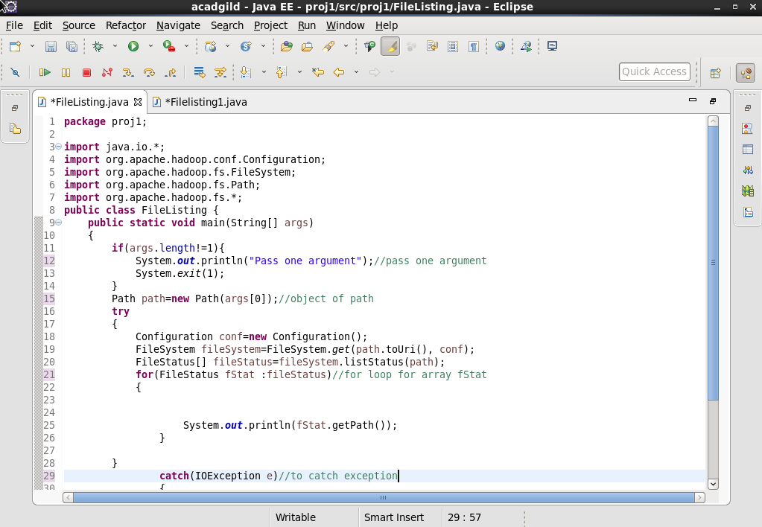

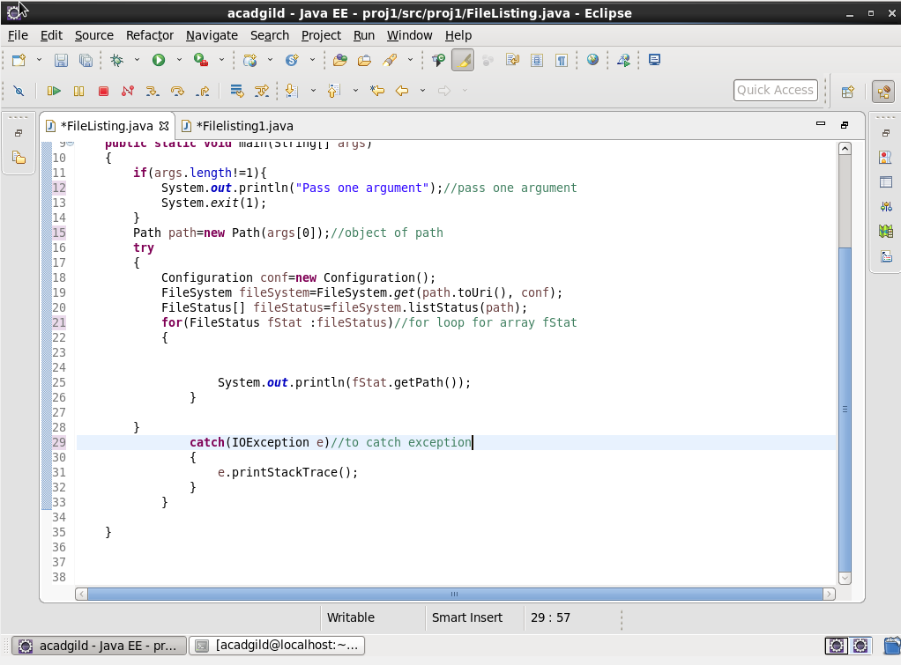

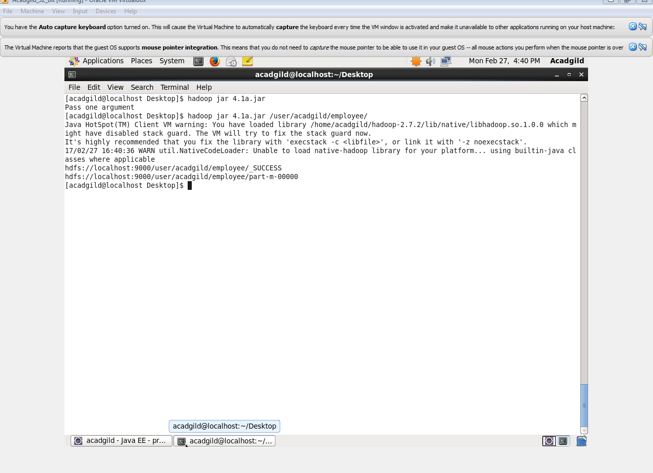

Problem Statement2

Modify the previous program to list all the files and sub-directories in the HDFS path recursively.

ans

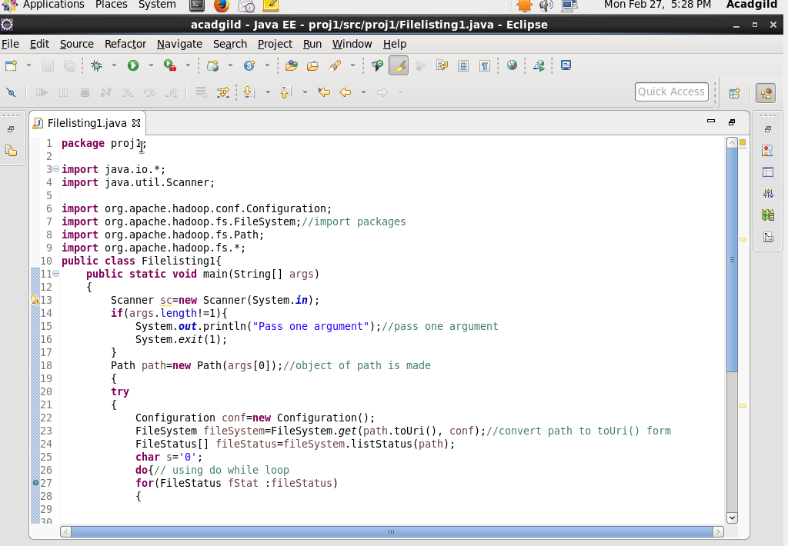

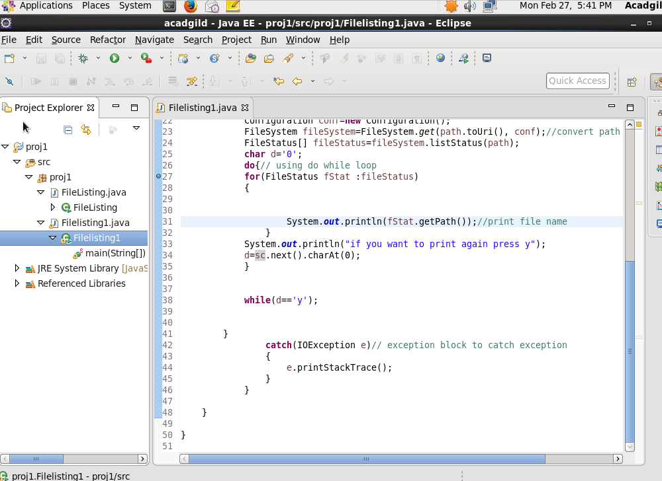

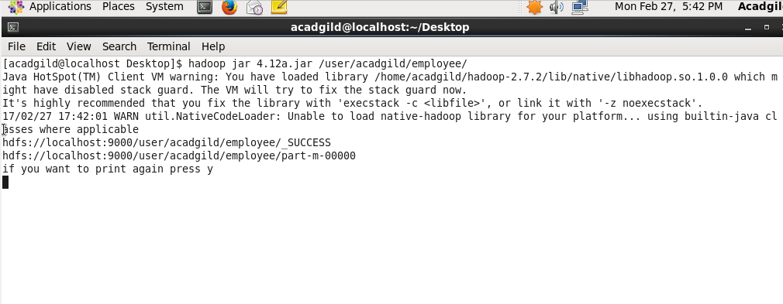

Problem Statement3

Modify the previous program to take multiple HDFS paths (separated by space) and list all the files and sub-directories in those HDFS paths recursively